To launch Jenkins

Open command prompt type

Java-jar C:\Jenkins\jenkins.war

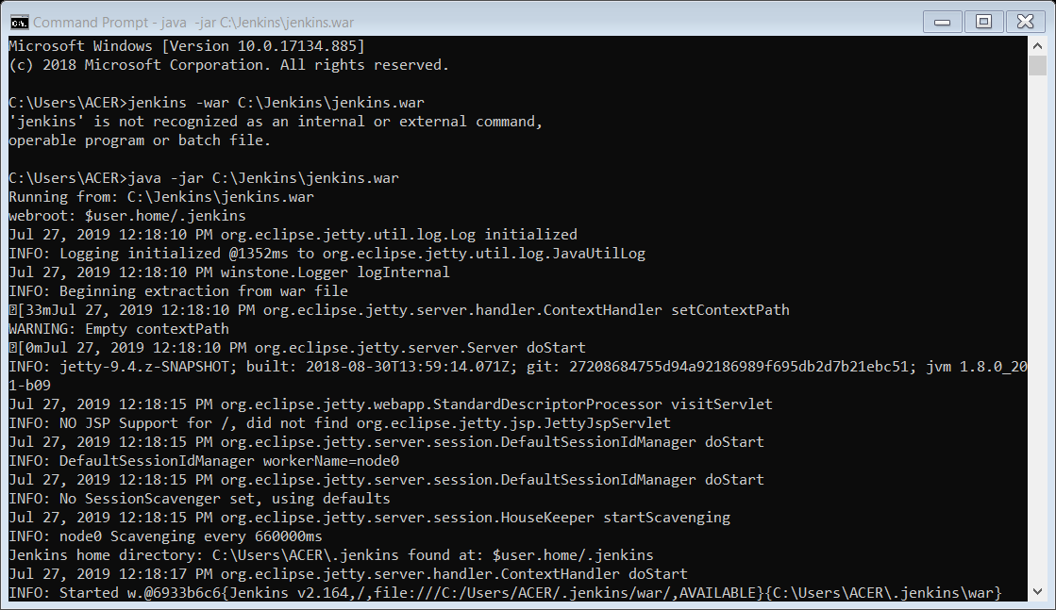

Open chrome

Type localhost:8080

Login with the user id – log2jeet24

Password – Ajiten#1990

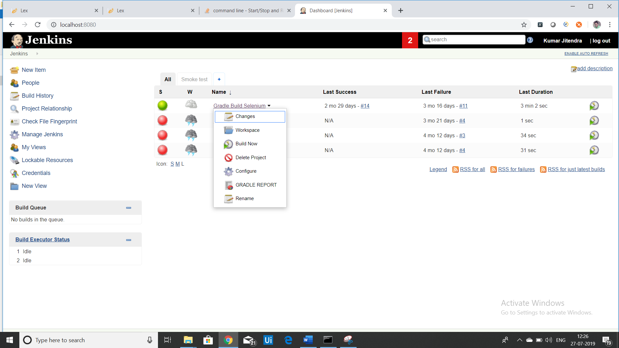

Click on build now

